

Your child’s sleep at 3 - 5 Years
Sleep is not under our control and cannot be forced
Your sleeping child
At this stage your child will be sleeping for around 11-13 hours. At three years they may have a 30 - 60 minute nap a day, but by five years almost all will have stopped napping completely. Their physical sleep is comparable to an adult, however emotionally it is a very different matter.
All children are different with their own personalities; some will sleep longer than others.
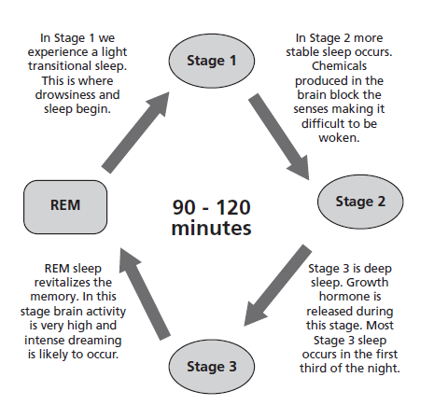
What can affect sleep?
- Starting pre-school/school For many children at this age, they will have a sleep regression. There are many new experiences and challenges which affect their mental stimulation, and therefore sleep.
- Night-time wetting It is still completely normal for a child at this age not to be dry at night, however when supporting your child to see if they are ready to sleep without nappies, they may have disturbed nights.
- Nightmares These are common and night terrors occur in around 3% of children. For specific support please speak to the children’s health team who can support you and your child.
- Common ailments Coughs, colds, nasal congestion, eczema, teething, and chicken pox may impact on your child’s comfort levels during the night affecting their ability to settle. Treating these as appropriate will help your child settle back into their usual sleep pattern.
- Change The arrival of a new sibling.

Your child’s development
- At this age, your child will be very curious, asking lots of questions. They often want to be like you and will copy your words and actions.
- Children at this age, particularly the younger ones, will still struggle with emotions which may be displayed as tantrums in around a fifth of children.
- Your child will be developing complex social play with fantasy and drama.

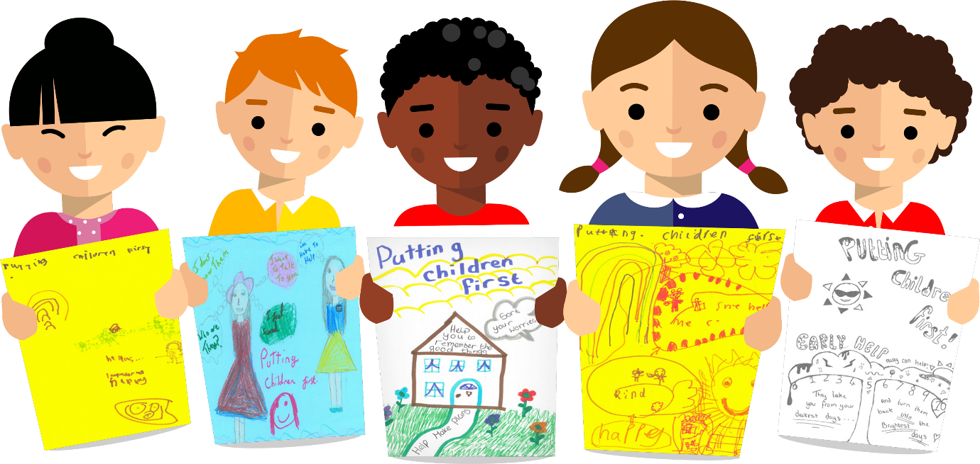

Ideas to support you and your child
- Reconnect with your child at the end of the day They need to feel your unconditional love. Try moving their bedtime to a slightly later time when they have had a busy day at pre-school or school and use this extra time to discuss their day and be together.
- Respond calmly Nurture yourself enough to be able to take in your child’s feelings and sometimes overwhelming emotions. Respond calmly and lovingly, especially at night. Make them feel happy and secure in their sleeping environment.
- Involve your child Get your child to choose their bedroom environment, such as the décor and contents to make it their own personal space.
- Temperature Keep the temperature in the bedroom at a comfortable temperature, ideally 16-18 degrees Celsius. Ensure their bed is comfortable; try lying on it yourself.
- Always end the day with praise and happy thoughts Bear this in mind when choosing their bedtime story and avoid screen activities leading up to bedtime as it prevents melatonin production (the sleep hormone). Fine motor skill activities such as jigsaws, colouring and playdough are more calming and aid relaxation. A bath may help.
- Drinks Certain drinks near to bedtime can over stimulate the bladder e.g., blackcurrant juice, caffeine and hot chocolate and results in in disturbed sleep. More soothing drinks include warm milk or water. It is normal for children to be in nappies at night-time at this age.
- Comforts Your child may have a special comfort object for bedtime, a spare one may be helpful in case it gets lost or needs a wash.
- Night lights A child at this age may become frightened of the dark. Having a night light can be comforting (red light bulbs are thought to be restful).
- Stimulation No technology (TV, handheld games, iPad etc) in their bedroom is important as it can be over stimulating, preventing them from falling asleep easily.
- Consistency Bedtime consistency at this age plays an important role in making your child feel secure. They can be actively involved in the bedtime routine, such as choosing their bedtime stories.
- Reassurance If your child needs reassurance by your presence when settling to sleep at night, consider staying in the bedroom for a while. Make yourself comfortable and engage yourself in a relaxing activity such as reading or listening to music through headphones. Your presence alone may be all that is needed. You may wish to slowly reduce the amount of time that you are in their room.
- Alleviating distress If your child is becoming distressed during this process, you could try staying in the bedroom longer and offering more comfort. It will take time, but this is okay and will resolve.
As a service we do not recommend any sleep modification/training techniques that involve leaving your child to cry, such as controlled crying, pick up/put down. Recent evidence highlights the importance of responding to all their needs responsively, to achieve optimum health and emotional wellbeing for your child.
For further support or information please contact your Children’s Health Team on 01522 843000.
For more information on how children sleep please visit The Sleep Charity at Home - The Sleep Charity

