
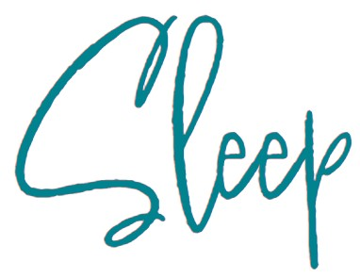
Your baby’s sleep at 3 - 6 months
Sleep is not under our control and cannot be forced.
Some things to remember
- Most parents know a new baby will affect their sleep, but there are many sleep myths that can lead to anxiety and distress. Some important things to know are:
- In the first few months baby sleep varies greatly, some sleep 8 and others 20 hours in 24.
- Young babies have no body clock and sleep in short bouts throughout the day and night.
- Young babies have small stomachs, and will wake every 2-3 hours to be fed.
- Night-feeds help breastfeeding mums make plenty of milk.
- By 3 months some babies (but not all) will skip a night feed and sleep for 5 or so hours.
- Many babies begin night-waking again at 4-5 months (some never stopped).
- By 5 months about half of all babies may sleep for an 8 hour stretch on some nights.
- Many babies begin night-waking again at 8-9 months (some never stopped).
- Most babies do not begin sleeping all night, every night, until they are a year or older.
- By 1 year old a third of babies have never slept for an entire night without waking.
- All of the babies described above are normal and just have different sleep needs.
- So long as your baby is alert and happy when they are awake, then they are getting enough sleep.
- People often experience short periods of feeling low, irritable or anxious as they adjust to being parents, and get used to broken sleep. Adjust your family sleep times so you can sleep when your baby gets their longest sleep period.

Here’s how sleep happens:
- When it gets dark our brains release a hormone called melatonin, which makes us feel drowsy. Your baby’s sleep is governed by the sleep cycle (circadian rhythm). The sleep cycle lasts for 45-60 minutes, at the end of which your baby will either start another sleep cycle or wake up (eg if they are hungry, uncomfortable or excited). It is thought that the sleep cycle and arousal from sleep is a protective mechanism against Sudden Infant Death Syndrome (SIDS).
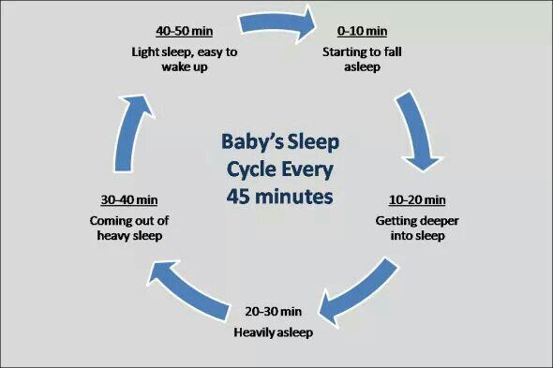

- A baby’s brain needs lots of energy as it is growing at a very fast rate, so babies need to be fed responsively. It is advised to have your baby in the same room as you (day and night for sleeping) for at least the first 6 months.
- The beginning and end of the sleep cycle is known as active sleep which is characterised by fluttering eyelids, rapid, irregular breathing, grunts or brief cries. At this point, pause to see if your baby will enter another sleep cycle. If you jump in too soon you might find yourself waking a sleeping baby!
- All babies are different and have their own personality – some will sleep longer than others.
- Sleep Pressure - We can only fall asleep when our bodies are relaxed and our brains are ready to switch off. Sleep pressure is the need to sleep that builds up the longer we are awake. Babies’ sleep pressure builds up more quickly than adults’. Sleep will happen more easily for your baby when sleep pressure has built up for a while.

How sleep pressure works
Babies fall asleep easily when their sleep pressure is high.
Young babies often need to sleep after being awake for an hour or two. As they get older sleep pressure builds more slowly, but it can take several years until they can stay awake all day. To build up sleep pressure for the night-time, let your baby take short naps during the day so their sleep pressure does not return to zero. There is no need to put them in a dark silent room as if it is night-time – they will take just as much sleep as they need and keep the overall sleep pressure rising to the end of the day.
If your baby has not built up enough sleep pressure they cannot fall asleep just because you want them to! Trying to make your baby go to sleep before they are ready will ‘dial them up’ and have the opposite effect. Figure out how to work WITH your baby’s sleep.

Recognising sleep cues
These can vary from baby to baby, but you will begin to recognise your own baby’s cues over time. The cues will also change as they grow.
They may yawn, rub their eyes, pull at their ears, become quieter, or you may notice them frowning, pulling their hair, being less engaged and responsive, a glazed look, drooping eyes, they may want to suck/feed, or arch backwards. However, becoming irritable and beginning to cry are late signs and can lead to your baby becoming over tired.

What can affect sleep?
- Environment A soothing bedtime and night-time routine are so important to your baby to reduce stress and over stimulation.
- Minor ailments and teething These can both interfere with sleep.
- Sensory stimulation Artificial lighting affects sleep as it stimulates your baby’s brain, which reduces the effects of melatonin, making it more difficult for your baby to fall asleep.
- Growth and development The excitement of learning new skills such as rolling over and other developmental milestones can affect your baby’s sleep pattern. Sometimes parents can mistake these night awakenings for hunger and want to wean baby early, but this does not help your baby to sleep through.
Between 3- and 6-months babies become aware of their own feelings and are starting to form strong emotional attachments to you e.g., they can get upset when they wake at night, and you are not there. This is a normal and part of their development.
You will be continuing to get to know your baby as they are developing at a fast rate. You may notice them waking more frequently for feeds and this be a growth spurt, which usually last for a few days.
Your baby will want to be close to you day and night, you cannot spoil your baby with love, cuddles, and attention. Keeping your baby close releases oxytocin, known as ‘the love hormone,’ in both you and your baby, making you both feel relaxed and calm. Studies suggest that babies who are held, have all their needs met and are not left to cry for long periods, will cry less, be more settled and become more confident toddlers and children.
Phases of increased night feedings are usually relatively short-lived. They are common between 4-6 months (but not a sign of weaning readiness!)

Your baby’s development
• At 3-4 months your baby will have an awareness of being in the world. They will not yet understand that you are a separate person but will know that when you meet their needs it makes them feels safe and happy.
• Physical strength develops, and at 4 months they will be interested in their surroundings, grasping at objects, and looking at their hands. By 4-6 months they will be rolling over and showing enjoyment by laughing and kicking their legs.
• At 3-6 months there will be further leaps in brain development, and the beginning of language with babbling and cooing. What a lot is going on! Imagine how exhausting, exciting and at times frustrating this time is for your baby.

Ideas to support you and your baby.
• Environment. A consistent day and night-time routine could help your baby tune into their natural body clock. Getting up at the same time each day is recommended – if your baby is still asleep, treat it like a daytime nap, open the curtains, let some fresh air in if the weather is appropriate and carry on with your normal day.
During the daytime, your baby will benefit from lots of stimulation and exposure to sunlight, so take them out, do lots of interesting things that you can both enjoy e.g., a walk in the park, or activities at your local library and children’s centre. Your baby may respond well to a consistent bedtime routine, such as having a bath, dimming the lights, darkening the room, and reducing overhead lighting. You may also want to consider black out curtains or thicker curtains in your baby’s room during the summer months.
• Practical ideas. It may help to bring your baby’s bedtime closer to your own, as some babies do better when they go to bed later. Make sure your baby is getting the right social cues about day and night. If they get lots of stimulation before bedtime this may make it harder to learn that bedtime is for sleeping.
Some relaxing activities for your baby and you before bedtime include cuddling, feeding, being carried while walking, skin to skin and having a bath. Babies like to look at books from an early age so you may like to make this part of your bedtime routine.
For further support or information please contact your Children’s Health Team on 01522 843000, especially if:
- By 8-12 weeks, your baby is waking every hour (or less) every night.
- If your baby is unhappy following feeds or needs to feed for long periods, at any age.
- If you are feeling overwhelmed or have low mood lasting for more than a few weeks.

For more information on how babies sleep, where babies sleep, sleep safety and SIDS see the Baby Sleep Info Source at www.basisonline.org.uk
For more information about breastfeeding and sleep see LaLeche League at Breastfeeding at night - La Leche League GB
