
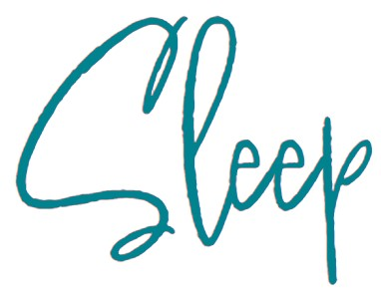
Your baby’s sleep at 6 - 12 months
Sleep is not under our control and cannot be forced.
Some things to remember
- By 5 months about half of all babies may sleep for an 8 hour stretch on some nights.
- Many babies begin night-waking again at 8-9 months (some never stopped).
- Most babies do not begin sleeping all night, every night, until they are a year or older.
- By 1 year old, a third of babies have never slept for an entire night without waking.
- All of the babies described above are normal and just have different sleep needs.
- So long as your baby is alert and happy when they are awake, then they are getting enough sleep.
- 6 - 9 months - Your baby may sleep up to 14-15 hours in a 24 hour period, including 1-3 naps during the day.
- 9 - 12 months - Your baby may sleep up to 13-14 hours in a 24 hour period, including at least 1 nap during the day.
- It is usual for babies at these ages to still wake for feeds during the night.

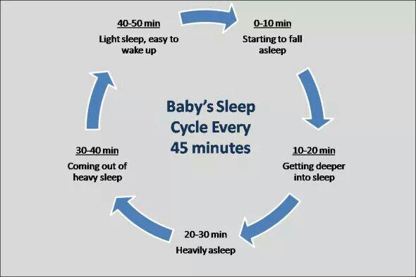

Recognising sleep cues
Sleep cues can vary from baby to baby, but you will begin to recognise your own baby’s cues over time. The cues will also change as they grow. They may yawn, rub their eyes, pull at their ears, become quieter, or you may notice them frowning, pulling their hair, being less engaged and responsive, a glazed look, drooping eyes, they may want to suck/feed, or arch backwards. However, becoming irritable and beginning to cry are late signs and can lead to your baby becoming over tired.

Sleep Pressure
We can only fall asleep when our bodies are relaxed and our brains are ready to switch off. Sleep pressure is the need to sleep that builds up the longer we are awake. Babies’ sleep pressure builds up more quickly than adults’. Sleep will happen more easily for your baby when sleep pressure has built up for a while.

How sleep pressure works
Babies fall asleep easily when their sleep pressure is high.
Young babies often need to sleep after being awake for an hour or two. As they get older sleep pressure builds more slowly, but it can take several years until they can stay awake all day. To build up sleep pressure for the night-time, let your baby take short naps during the day so their sleep pressure does not return to zero. There is no need to put them in a dark silent room as if it is night-time – they will take just as much sleep as they need and keep the overall sleep pressure rising to the end of the day.
If your baby has not built up enough sleep pressure they cannot fall asleep just because you want them to! Trying to make your baby go to sleep before they are ready will ‘dial them up’ and have the opposite effect. Figure out how to work WITH your baby’s sleep.

Recognising sleep cues
These can vary from baby to baby, but you will begin to recognise your own baby’s cues over time. The cues will also change as they grow.
They may yawn, rub their eyes, pull at their ears, become quieter, or you may notice them frowning, pulling their hair, being less engaged and responsive, a glazed look, drooping eyes, they may want to suck/feed, or arch backwards. However, becoming irritable and beginning to cry are late signs and can lead to your baby becoming over tired.

What can affect sleep?
- Environment Artificial light can stimulate your baby’s brain making it more difficult for them to fall asleep.
- Sensory stimulation calm and relaxed bedtime routine is important.
- Underlying medical problems (e.g., reflux)
- Minor ailments (e.g., coughs/colds)
- Teething
- Changes in usual routine, eg

Your baby’s development
- Growth spurts (age 6 and 9 months). During a growth spurt your baby will put on weight, grow in length, and head circumference more quickly than usual. Your baby may also master a skill that they have been working on for a while. Babies going through growth spurts may become clingy, fussy, and unsettled, and this can disrupt nap times and night-time.
- Your baby may begin to roll and pull themselves to stand at this age.
- Introduction of solids is an exciting time but does not necessarily mean your baby will start sleeping through.
- Separation anxiety (may begin around 8 months). This is part of emotional growth - your baby needs to trust that you will come back to them when they need you. They may only respond to one carer or those close to them, which is okay and will resolve.

Ideas to support you and your baby
- Have a set routine during the day and open the curtains for exposure to daylight. At bedtime have a consistent routine and consider using blackout blinds which may support your baby’s own sleep rhythms.
- Help your baby understand their own circadian rhythm (sleep-wake cycle) with exposure to daylight when they wake and keeping the environment dark during the night, to support a good daytime and night-time routine.
- Limit stimulation before the bedtime routine starts, by reducing the light, screen time (no use of TV, tablet, or smart phone an hour before going to bed) and background noises to encourage a calm and relaxed atmosphere. Red night lights are thought to be helpful too.
- Recognise sleep cues. Is your baby sleepy, hungry, unwell, too hot? A later bedtime might help.
- Be responsive to your baby’s needs but offer a relaxed response. They may just be finding their own comfort.
- Relaxation techniques. Baby massage and yoga can add to a positive, calm routine.
- Time out for you. Try mindfulness – visit NHS Choices or apps such as Headspace.
- Allow another carer to attend to your baby if possible.
As a service we do not recommend any sleep modification/training techniques that involve leaving your baby/child to cry, such as controlled crying, pick up/put down. Recent evidence highlights the importance of responding to all their needs responsively, to achieve optimum health and emotional wellbeing for your child.
For further support or information please contact your Children’s Health Team on 01522 843000.
For more information on how babies sleep, where babies sleep, sleep safety and SIDS see the Baby Sleep Info Source at www.basisonline.org.uk

