

Your baby’s sleep.
What you need to know in the Antenatal period

Sleep is not under our control and cannot be forced
Some things to remember
- In the first few months, sleep varies hugely--babies may sleep from 8-20 hours in 24.
- Young babies have small stomachs and will wake every 2 hours or so to be fed and comforted.
- Newborns have no body clock and sleep in short bouts throughout the day and night.
- After 3 months some babies (but not all) will skip a night feed and sleep for 5 or so hours. BUT many babies begin night-waking again at 4-5 months and some continue to wake frequently. This is all normal.
- Most babies do not sleep all night, every night, until they are a year or older.
- By 1 year old a third of babies have never slept for an entire night without waking.

Here’s how sleep happens:
- There is a huge variation in the amount of time your baby will sleep - it can range from just over 9 hours to 20 hours in a day.

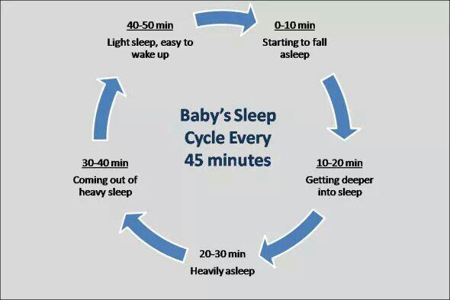

- Sleep cycles are short at about 45 minutes. Your baby has a very small stomach and needs to feed around the clock to meet their needs. Although managing night feeds can be challenging, it is also a quiet time away from the busyness of the day. It’s not until around 8-12 weeks that your baby’s circadian rhythm (sleep-wake cycle) matures enough for them to begin to tell night from day.
- Sleep development does not develop in a straight line (see diagram)

- New babies have increased amounts of Rapid Eye Movement (REM) sleep so will wake more easily. It is thought that the sleep cycle and arousal from sleep is a protective mechanism against Sudden Infant Death Syndrome (SIDS).
- It is advised that you have your baby in the same room as you (day and night when sleeping), until at least 6 months of age.

- A baby’s brain needs lots of energy as it is growing at a very fast rate, so babies need to be fed responsively.
- Sleep Pressure - We can only fall asleep when our bodies are relaxed and our brains are ready to switch off. Sleep pressure is the need to sleep that builds up the longer we are awake. Babies’ sleep pressure builds up more quickly than adults’. Sleep will happen more easily for your baby when sleep pressure has built up for a while.

How sleep pressure works
Babies fall asleep easily when their sleep pressure is high.
Young babies often need to sleep after being awake for an hour or two. As they get older sleep pressure builds more slowly, but it can take several years until they can stay awake all day. To build up sleep pressure for the night-time, let your baby take short naps during the day so their sleep pressure does not return to zero. There is no need to put them in a dark silent room as if it is night-time – they will take just as much sleep as they need and keep the overall sleep pressure rising to the end of the day.
If your baby has not built up enough sleep pressure they cannot fall asleep just because you want them to! Trying to make your baby go to sleep before they are ready will ‘dial them up’ and have the opposite effect. Figure out how to work WITH your baby’s sleep.

Recognising sleep cues
These can vary from baby to baby, but you will begin to recognise your own baby’s cues over time. The cues will also change as they grow.
They may yawn, rub their eyes, pull at their ears, become quieter, or you may notice them frowning, pulling their hair, being less engaged and responsive, a glazed look, drooping eyes, they may want to suck/feed, or arch backwards. However, becoming irritable and beginning to cry are late signs and can lead to your baby becoming over-tired.
What can affect sleep?
- Environment The first 3 months of your baby’s life, moving from the security of the womb to the outside world, is a period of huge change. Keeping their environment calm and quiet can help with this transition.
- Minor ailments Coughs, colds, gastro-intestinal upset.
- Sensory stimulation This can lead to your baby being unable to fall asleep easily and they may appear unsettled, cry, and take a lot longer to relax into sleep.
- Changes in routine Going away on holiday or moving house.
- Growth and development This is a time when you will be getting to know your baby and when they will be growing and developing at an amazingly fast rate. You may notice your baby waking more for feeds which may indicate a growth spurt, which usually last for just a few days.

Your baby’s development
They will start to smile and to make cooing sounds; these are the beginnings of speech and communication. When you are talking to your baby you may notice them pausing to listen, this is the two-way process of communication developing. All this interaction with your baby will be helping to stimulate their brain. Babies are born with millions of nerve pathways in their brain and the more these are stimulated the more they will grow and become permanent.
Your baby will want to be close to you day and night, you cannot spoil your baby with love, cuddles, and attention. Keeping your baby close releases oxytocin, known as ‘the love hormone,’ in both you and your baby, making you both feel relaxed and calm. Studies suggest that babies who are held, have all their needs met and are not left to cry for long periods, will cry less, be more settled and become more confident toddlers and children.

Ideas to support you and your baby
Environment Keep the environment as calm as possible, limiting visitors to reduce overstimulation. Natural daylight in the day and dim lighting (red lights are thought to be helpful) at night. Babies may find night-time too quiet, so white noise may help.
Relaxation Keep your baby close and have skin-to-skin contact, do baby massage, or have a warm bath with your baby. Using a sling will allow you to have your hands free and to keep your baby close so they can hear your heartbeat and be settled by your gentle movements.
Feeds You will begin to notice your baby’s cues for feeding. It is a good idea to feed your baby when you see or hear early feeding cues, such as sucking fingers, restlessness, or murmuring sounds. This will help your baby remain relaxed and more likely to be able to go back to sleep easily after the feed. When feeding, paced and responsive feeding can stop your baby feeling overfull or uncomfortable, both of which could affect sleep. Night feeds are important to nourish your baby.
Practical ideas If you have someone to support you, they can help with nappy changing in the night, and with jobs around the house such as cooking and cleaning. Keep your baby close to you at night to make night-time feeds easier. When organising feeding, bring boiled water upstairs in a flask to help minimise disruption. Try to rest or sleep in the day when possible, using mindfulness techniques to help with relaxation - use NHS Choices or apps such as Headspace.
As a service we do not recommend any sleep modification/training techniques that involve leaving your baby/child to cry, such as controlled crying, pick up/put down. Recent evidence highlights the importance of responding to all their needs responsively, to achieve optimum health and emotional wellbeing for your child.
For further support or information please contact your Children’s Health Team on 01522 843000, especially if:
- By 8-12 weeks, your baby is waking every hour (or less) every night.
- If your baby is unhappy following feeds or needs to feed for long periods, at any age.
- If you are feeling overwhelmed or have low mood lasting for more than a few weeks.
For more information on how babies sleep, where babies sleep, sleep safety and SIDS see the Baby Sleep Info Source at www.basisonline.org.uk
For more information about breastfeeding and sleep see LaLeche League at Breastfeeding at night - La Leche League GB